FIVE HEART CHAMBERS AT 60 YEARS: A RARE PRESENTATION OF COR TRIATRIUM SINISTRUM
A.S. Saggu¹, A.S. Rajabalan¹, S.V. Patel¹, P. Patel¹, T. Singh¹
¹Western Reserve Health Education/NEOMED, Youngstown, OH, USA

Introduction: Cor-triatrium is a rare congenital cardiac anomaly in which a fibromuscular/membranous septum divides the left (sinistrum) or the right (dextrum) atria into a total of 3 chambers and hence 'triatrium’. We present a case of 60 year old lady with Cor-Triatrium Sinistrum (CTS) with concomitant CAD who underwent CABG and successful repair of CTS.
Case description: A 60-year-old Caucasian woman with h/o dyslipidemia presented with progressive dyspnea and fatigue for 1 year. Physical examination was unremarkable. 2D Echo showed an EF of 70% with moderately dilated left atrium (LA) with no valvular abnormalities. However, a diastolic gradient was present across a structurally normal Mitral Valve (MV), hence CTS was suspected. Findings of CTS were confirmed by a TEE. Right and left heart catheterization prior to surgery showed multi-vessel disease. On surgical exploration, a 3.9x3.1x0.1 cm membrane was seen just distal to the pulmonary veins in the LA with a nickel sized opening in the middle. CABG and removal of membrane were performed. Immediate postoperative period was uncomplicated and her symptoms improved.
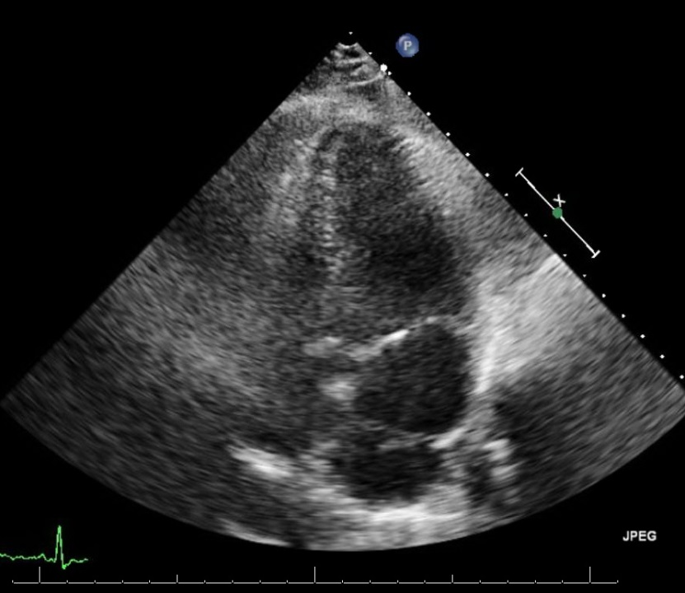
Discussion: Cor-triatrium is a rare congenital abnormality, found in approximately 0.1-0.4% of clinically diagnosed congenital cardiac malformations. Mal-incorporation of the common pulmonary vein into the LA is the most common cause of CTS, creating two chambers that may or may not be separated by an opening. CTS is usually symptomatic and is diagnosed in the pediatric age group, causing LA outflow obstruction mimicking mitral stenosis, or due to its association with other cardiac malformations in about 80% cases. CTS rarely remains asymptomatic till adulthood and the symptoms are based on the size of the membrane and/or the presence of fenestrations. Our patient presented at 60 years with exertional dyspnea subsequently diagnosed with CTS with concomitant CAD which is very rare, and not previously reported.

